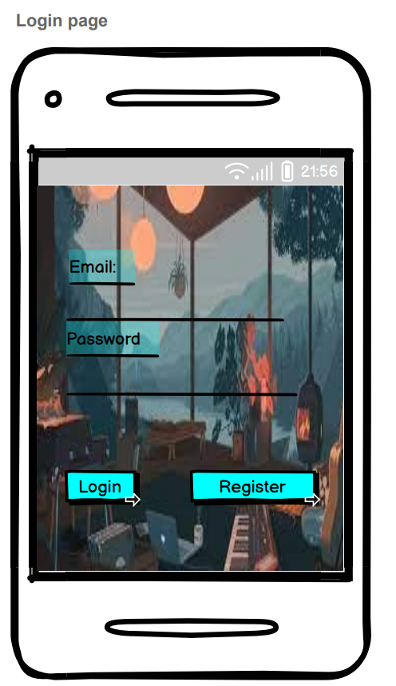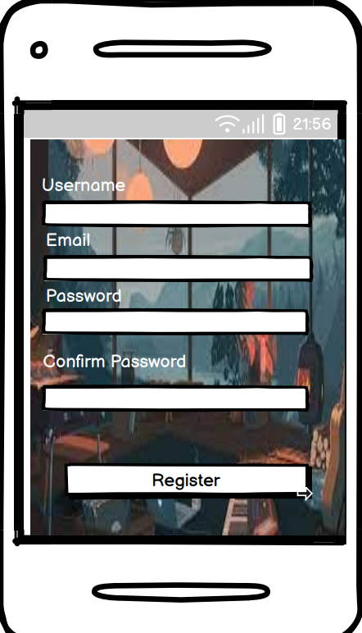

Above Diagram shows the first main function in this system which the register part and the login part . This system allows users to able to be logged into the system and start to make BUDDIES online ! In order to log into the Buddy system , users are asked to register as a member of this System which user need to input their username , email and password and also confirm their password . As usual , user’s username and email cant be duplicated . After registered as a member , users are able to log in and reach to the homepage

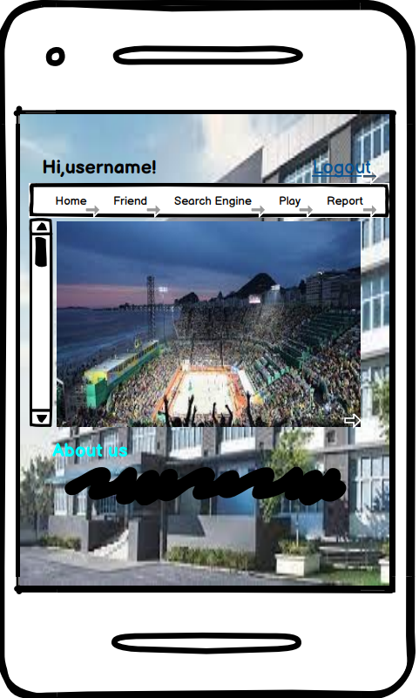

Diagram above shows the homepage of the INTI International College Penang (IICP)’s Buddy System Homepage. It has a Menu Bar which contain 5 functions which is go to friend page , go to search page , reaching to game’s homepage , report page and last but not least is the logout function on the right top of the screen.

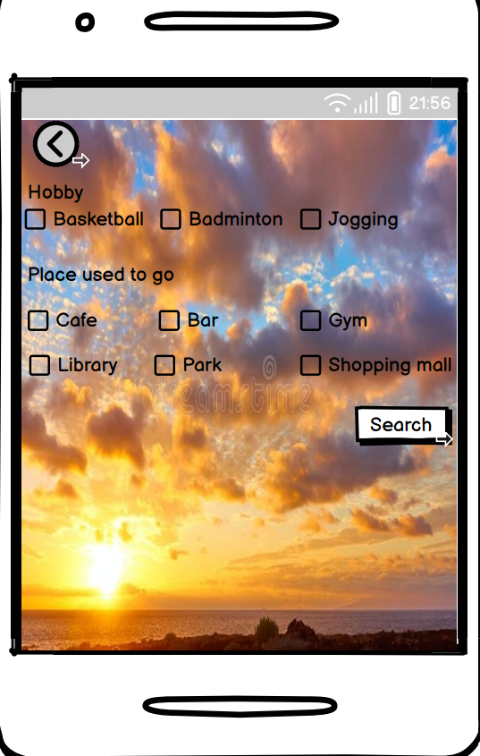

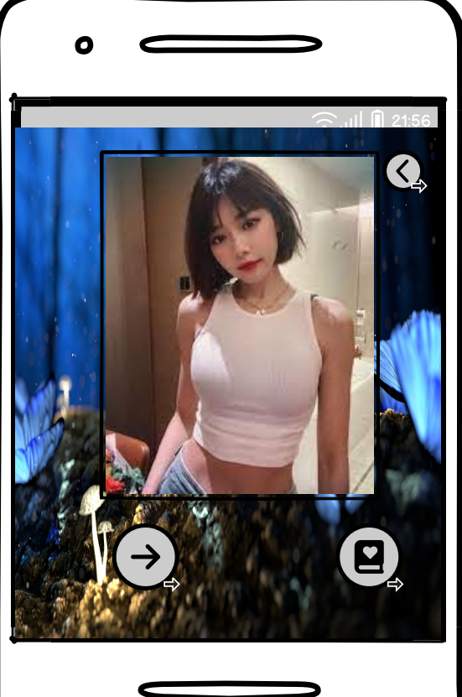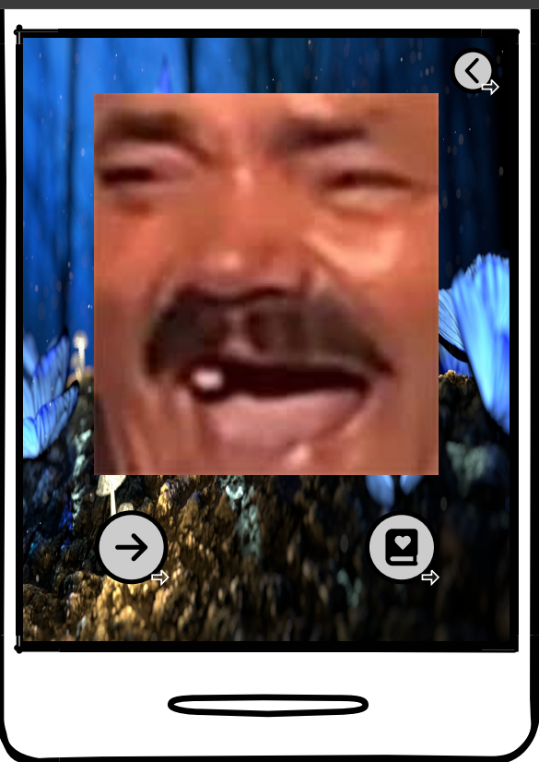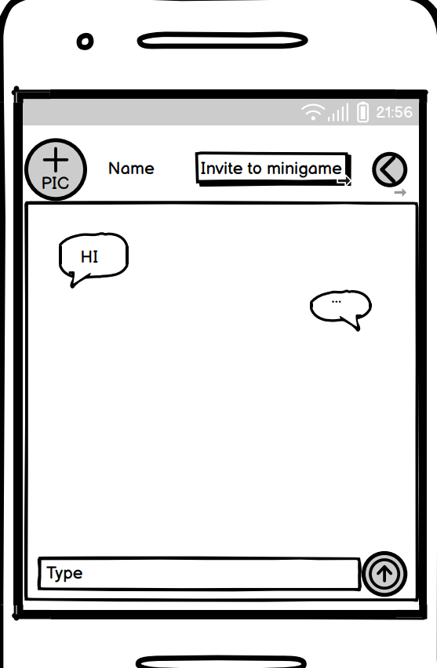

And here comes to the main function of this system , FINDING BUDDIES! At first , users are asked to choose the characteristics of his/her dream BUDDIES , then , the search button will bring the users to the friend page , which is the diagram with the blue background . If they found somebody which suits his / her attributes , the book button will bring them to the chat page so that they will be able to chat to each other .Besides , in one of the survey , users trust that playing minigames are able to get to know each other better . Hence , an game invitation button is set on the right top of the interface . After clicking it , system will sent an invitation link to the another users so that the another users can choose to accept or just ignore the invitation to the minigames sessions.

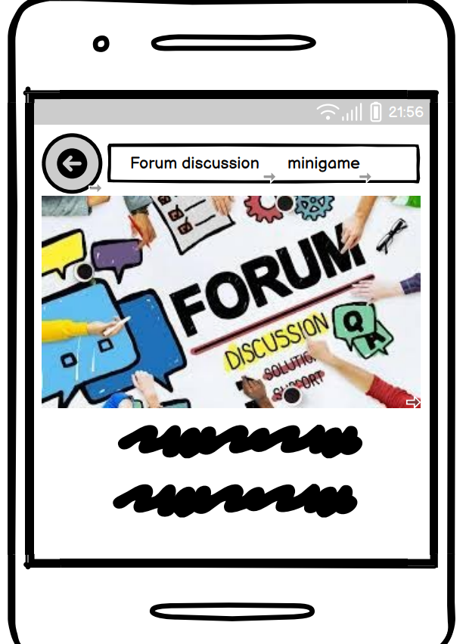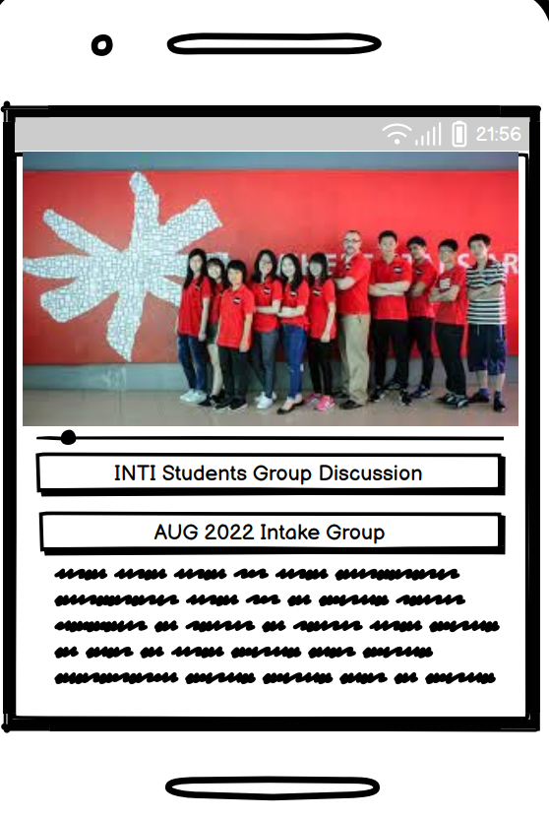

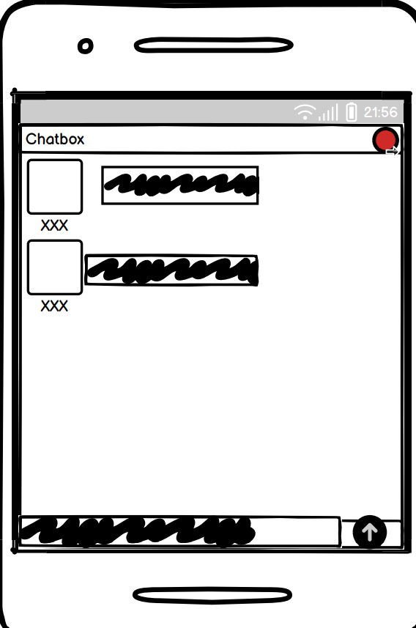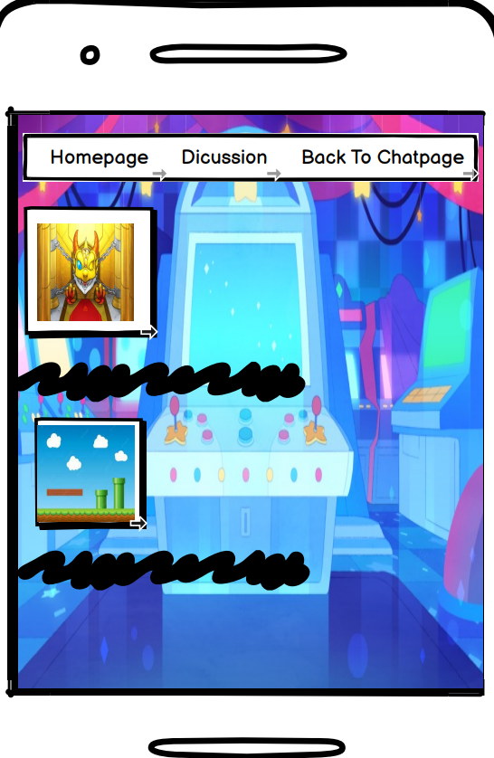

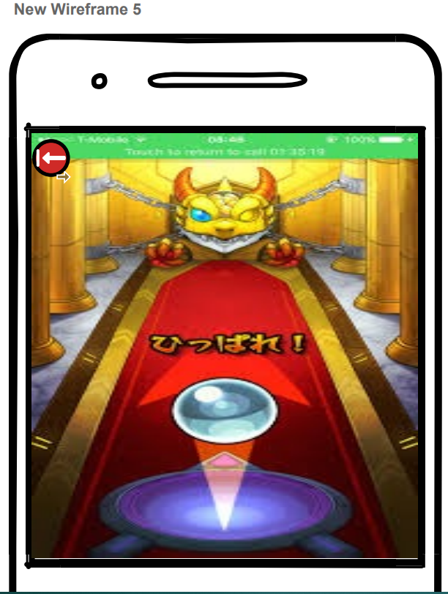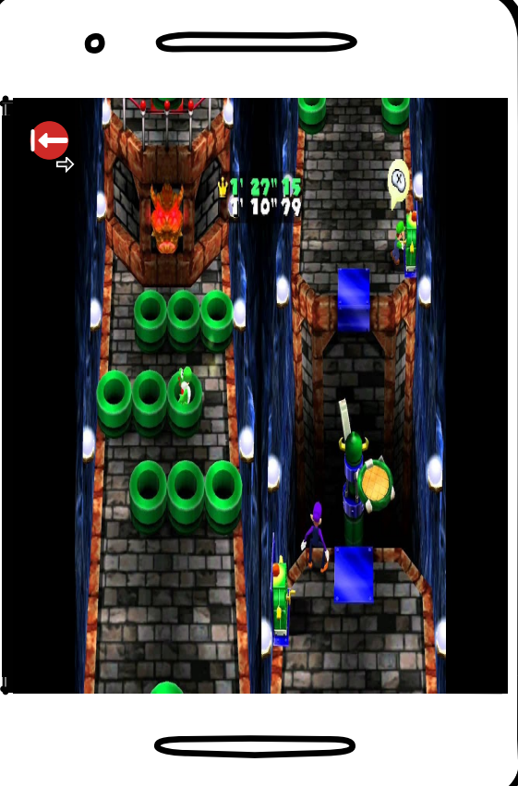

And here is the second main function of the BUDDY SYSTEM . It is the minigames and the forum discussion . At first in the Homepage , Users can hit the play button and system will bring users to the game’s home page which is the first diagram . Same as the main homepage , in this game homepage also included some functions which is reach to the forum discussion page or the game choosing page . When the users press the forum discussion button on the menu bar , user will be brought to the forum discussion page which included news , groups joined and some announcement made by the group leaders . After clicking the joined group button , users will be reaching the group discussion page , users can share their experience and also inviting group members to have a battle in the games . On the other hand , when users press the minigame button on the menu bar , user will be brought to the game choosing page . Gatcha game is always a game that can bring two users closer especially when they both get the same character . The picture that shows the dragon page is one of the kind of this game . Secondly is about the racing game , a classic time racing game which is Mario run , will help users to get to know each other and also closer in the relationship .

**USABILITY TEST QUESTION**

**Methodology**

The usability test will be carried out to gather assessment data about the effectiveness of our buddy system application . Participants will be randomly picked in the sixth floor of INTI International College Penang due to there will be a lot of person in a certain time . Participants will use this application to perform its main task which is to find buddy through the application . We will collect all the data about the successful rate and also about the feeling after using the application.

**We will use a guerilla testing method**

In this between-subject study , each participant will go through a task path which is already set by us . .It will only take about 15 to 30 minutes for the usability study sessions . Each participant will perform the task using the buddy system application . First 3 minutes I will be explaining the system usage and also call them to fill up the waiver form so that we can get the information of the users . Then we will be explaining the path so that participants can get to know what they need to do later . After that , participant will try to use the application and they will be pointing out the bug and we will record it . Participant experience will be recorded through a Google form and we will collect the personal data too.

**Session outline and timing**

The test session will be around 15 to 30 minutes of each session for pre-test introductions and post – test debriefing interviews . The session will be takes place in sixth floor of IICP.

**Pre test arrangement**

**Have the participant:**

**-Review and sign a deal for recording permissions and also for personal data .**

**-Fill out a background questionnaire**

**Introduction to the session(3 minutes)**

**Discuss:**

-Participant’s experience with usability test

-About the reason to choose area for doing testing

-Moderator’s role

-Recording system , observers ,etc.

**Background Interview (2 minutes)**

**-**Experience of making friends in IICP

-Reasons for difficulty in finding friends

**Task (10 minutes)**

Participants will start the path to find a buddy through our system .

**Post-test debriefing (5 minutes)**

**-Ask about the experience of the participants while using the system**

**-Fill up a google form to leave a contact and also the review of participants**

**Sample Questions.**

1. Did you have real good buddy in this time right in this college.(INTI INTERNATIONAL COLLEGE PENANG)?
2. If not , would you like to find one buddy?
3. If yes , would you like to find more buddy?
4. If no , may I know the reason why ? Did you have any difficulty in making friends?
5. If yes , that’s great ! We are developing a buddy system for the students in this college , later I will give you a prototype of this system and I might take few minutes to complete it , are you able now?
6. If yes , excellent.
7. If no , Thank you.
8. After test . So how is your experience in using this system , anything weird or somewhere else got bug?
9. Will you have some suggestion so that this system can be improved ?
10. May I take you sometime so that I can get you to this system once it is completely developed?